**Flask 2**

**Data Science Master’s Assignment**

**20th Feb 2023**

**Q1. Explain GET and POST methods.**

### Sol. GET

GET is the most commonly used HTTP method and it is typically used to retrieve information from a web server.

**POST**

POST is commonly used to send information to web server. It is more often used when uploading a file, getting form data and sending sensitive data. POST is a secure way to send data to a web server.

**Q2. Why is request used in Flask?**

**Sol.** In the client-server architecture, the request object contains all the data that is sent from the client to the server. As we have already discussed in the tutorial, we can retrieve the data at the server side using the HTTP methods.

**Q3. Why is redirect() used in Flask?**

**Sol.** Flask redirect is defined as a function or utility in Flask which allows developers to redirect users to a specified URL and assign a specified status code. When this function is called, a response object is returned, and the redirection happens to the target location with the status code.

**Q4. What are templates in Flask? Why is the render_template() function used?**

**Sol.** Templates are files that contain static data as well as placeholders for dynamic data. A template is rendered with specific data to produce a final document. Flask uses the Jinja2 template library to render templates. In your application, you will use templates to render HTML which will display in the user’s browser.

[render_template](https://github.com/pallets/flask/blob/master/src/flask/templating.py) is a [Flask](https://www.fullstackpython.com/flask.html) function from the flask.templating package. render_template is used to generate output from a [template file based on the Jinja2 engine](https://www.fullstackpython.com/template-engines.html) that is found in the application's templates folder.

**Q5. Create a simple API. Use Postman to test it. Attach the screenshot of the output in the Jupyter Notebook.**

**Sol.**

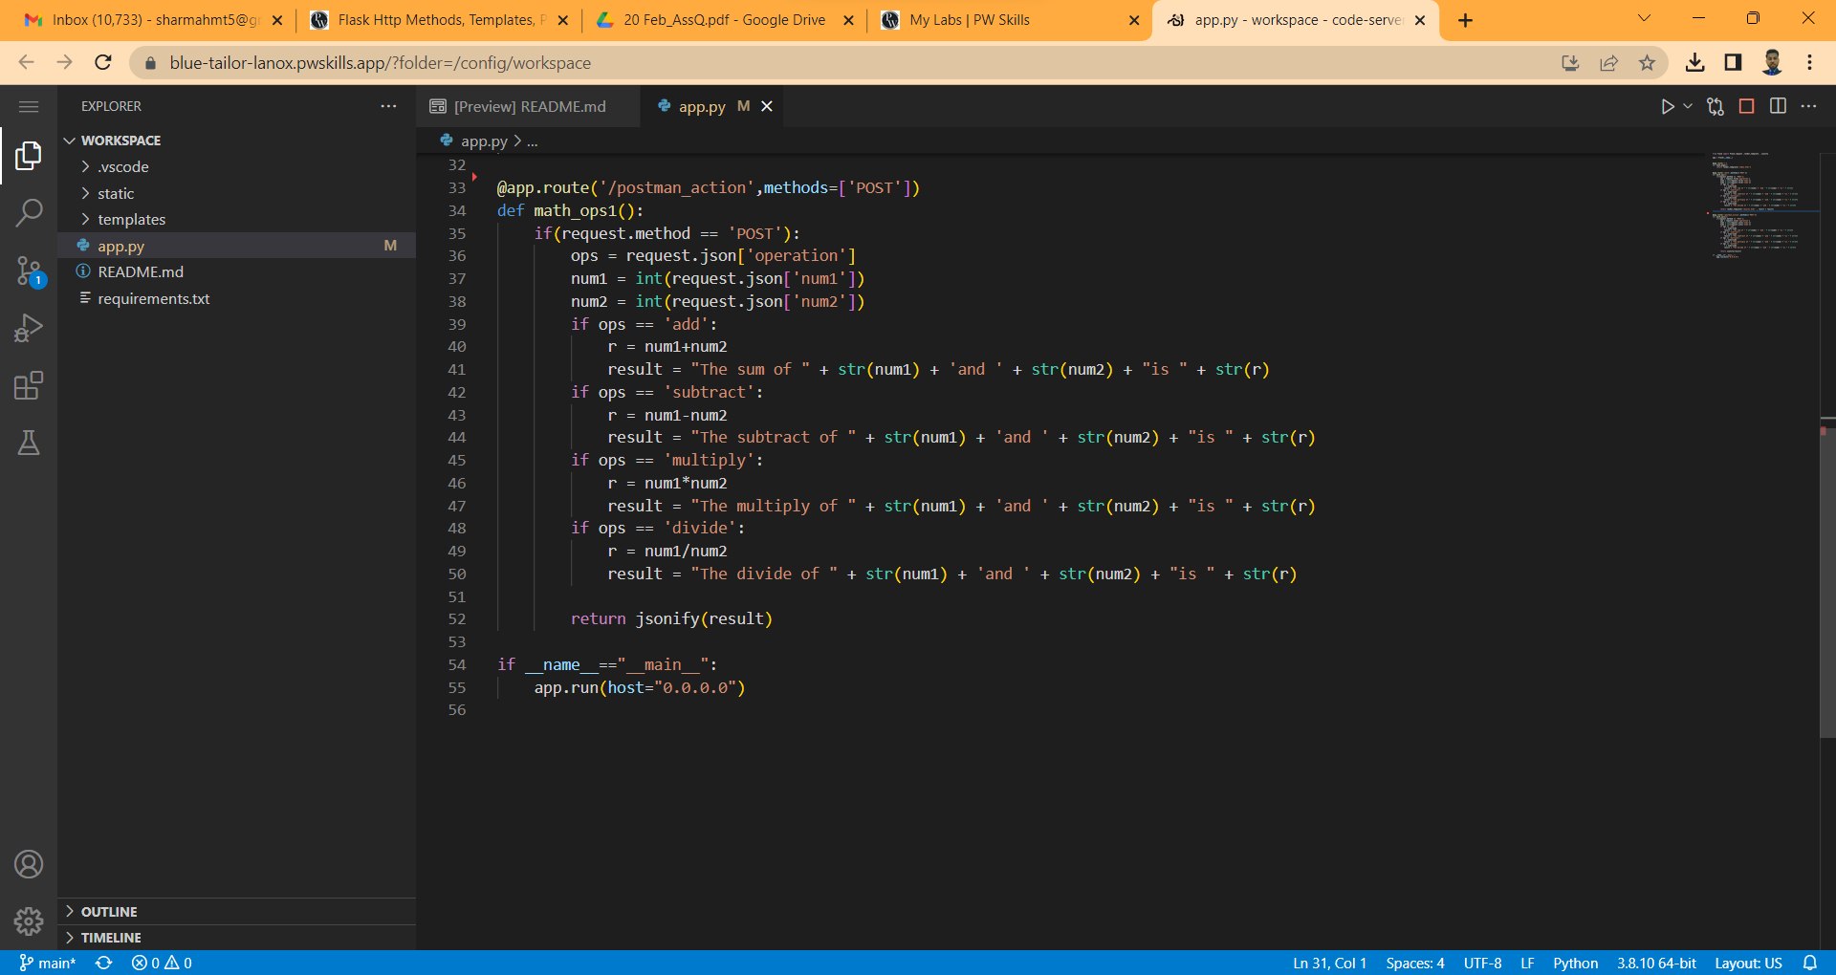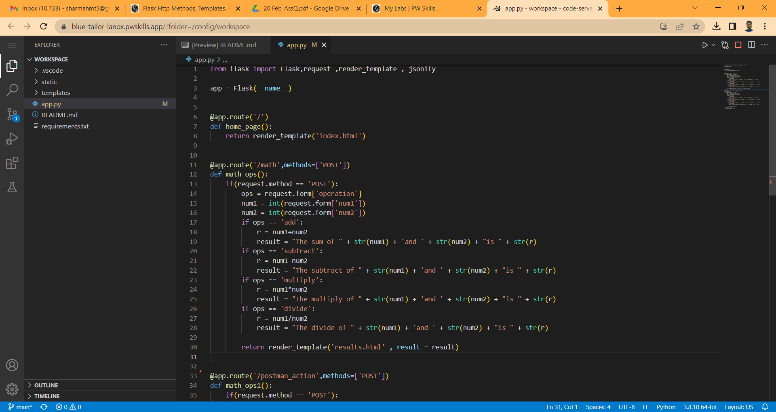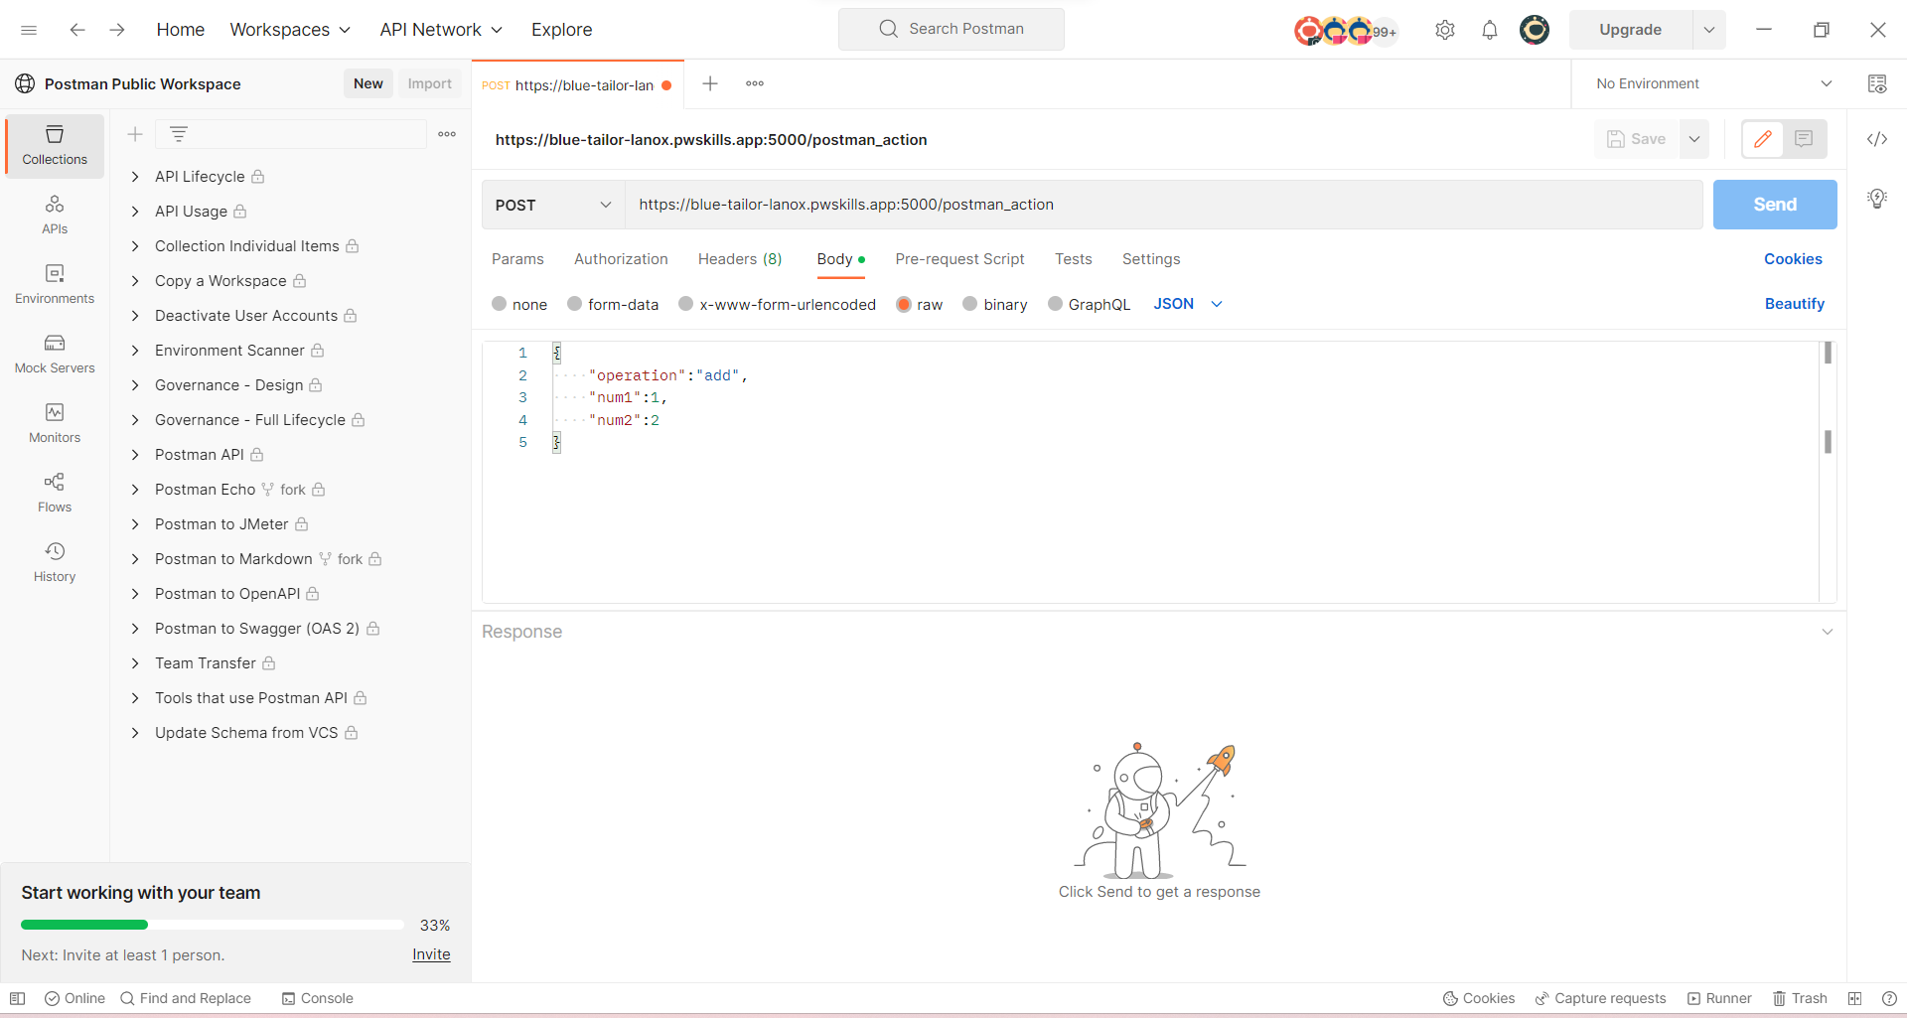

***NOTE:*** *During the testing of API something going wrong please check where is my mistake.*